Please personalize all of the highlighted areas, but don't forget to remove the highlight before sending to your legislator.
Name

Address
Email—Phone Number

Date: ___________________________
Representative/Senator Name
Address
City, State, Zip
Dear Representative/Senator:

My name is ____________ [please personalize this paragraph with information about you, to include that you live in the legislator’s district, if you have met this legislator, and whether you are a person with a disability, teacher, advocate, etc.]. I am writing to let you know about employment barriers facing individuals with disabilities in South Carolina and the importance of Employment First. Employment First means that employment in the community at competitive wages is the first and preferred option for individuals with disabilities.
Currently, 41 service providers in SC have 14(c) certificates that allow them to employ over 4,000 South Carolinians in segregated settings, where they may make less than $1 per hour, a practice called subminimum wage employment. While originally intended to be transitional job training programs, these Medicaid funded services often entail participants performing repetitive tasks not marketable to employers or matched to their skillset. Nationally, less than 5% of employment day program participants actually exit these programs into competitive employment.
South Carolinians like me/my family member/students/etc. are relying on lawmakers to disrupt the pipeline into sheltered workshops. People with disabilities should be valued members of South Carolina’s workforce and deserve employment opportunities and wage protections like any other worker. I would be happy to talk more by phone/e-mail/mail/in person and tell you my story. HireMeSC.org also has great resources to understand this issue better. I’ve enclosed an information sheet to give you a snapshot of disability employment in our state.
Sincerely,
[Signature]
Your Name

Inclusive Employment Today. Unlimited Promise Tomorrow.
Hire Me SC, an Employment First Initiative.

The South Carolina Employment First Initiative is a statewide effort to increase competitive and integrated employment outcomes for individuals with disabilities. Employment in the general workforce is the first and preferred option for individuals with disabilities receiving assistance from publicly funded services.

Competitive & Integrated Employment is:

- Working at least 20 hours a week
- Making minimum wage or more
- Equivalent pay to individuals without disabilities
- Working alongside individuals without disabilities
- Working within the local community

individuals in South Carolina have a disability
*Source: 2016 American Community Survey 1-year estimates

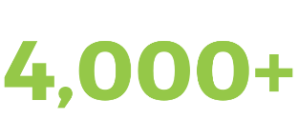
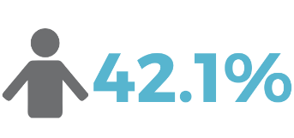
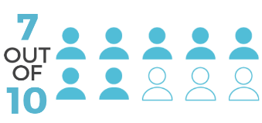
individuals with disabilities in South Carolina work in setting where they may earn less than $1 per hour.
Source: United States Department of Labor, Community Rehabilitations List
the employment gap for individuals with disabilities in SC compared to those without disabilities.
Source: 2017 Annual Disability Statistics Compendium
South Carolina’s unemployment rate for individuals with disabilities is one of the HIGHEST in the country.
Source: 2017 Annual Disability Statistics Compendium
individuals with disabilities are unemployed.
Source: 2017 Annual Disability Statistics Compendium

Employers consistently rate workers with disabilities as average or above average in performance, quality of work, flexibility to demands, attendance, and safety. Source: Virginia Commonwealth University

hiremesc.org @HireMeSC #HireMeSC

